快速使用与手动安装python环境：

1.安卓数据线接板子（图1）1口，板子上电，并且在电脑上识别出相应的接口，如图2
图1

图2

- 打开SecureCRTPortable，选择对应的端口，这里是com16.波特率115200,如图3

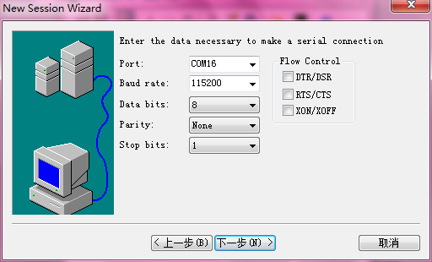
图3

3.回车后，可以登录控制台界面：

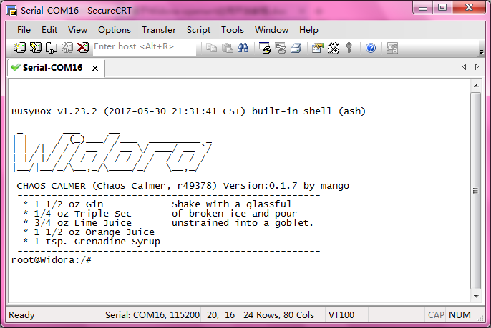

4.至此，一个标准openwrt系统已经成功运行，我们也能通各种命令与板子进行交互。

附信息：
板子硬件信息：32MB FLASH + 128MB DDR2

5.联网：
连接无线热点，输入192.168.1.1，在页面配置中继无线信息
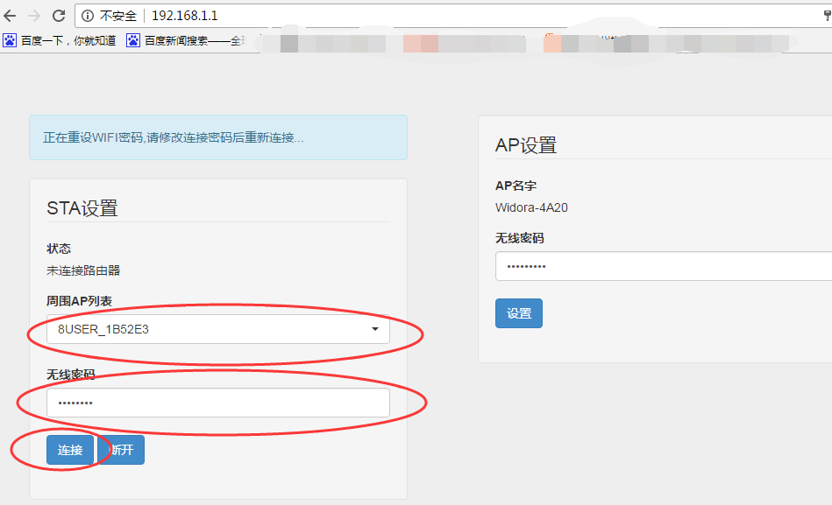

6.查看连接情况：
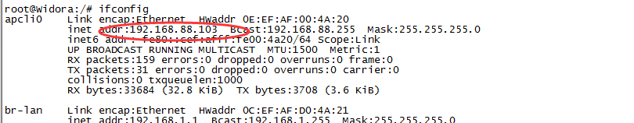
至此已经幸福的连上互联网~~

二．安装python
root@Widora:/www# opkg update
root@Widora:/www# cd /tmp/
root@Widora:/tmp# wget http://downloads.openwrt.org/chaos_calmer/15.05.1/ramips/
mt7688/packages/base/libbz2_1.0.6-2_ramips_24kec.ipk
Connecting to downloads.openwrt.org (78.24.191.177:80)
libbz2_1.0.6-2_ramip 100% |*******************************| 26097 0:00:00 ETA
root@Widora:/tmp# opkg install libbz2_1.0.6-2_ramips_24kec.ipk
Installing libbz2 (1.0.6-2) to root...
Configuring libbz2.
root@Widora:/tmp# opkg install python
Installing python (2.7.9-6) to root...
Downloading http://downloads.openwrt.org/chaos_calmer/15.05.1/ramips/mt7688/packages/packages/python_2.7.9-6_ramips_24kec.ipk.
Installing python-light (2.7.9-6) to root...
Downloading http://downloads.openwrt.org/chaos_calmer/15.05.1/ramips/mt7688/packages/packages/python-light_2.7.9-6_ramips_24kec.ipk.
Installing python-base (2.7.9-6) to root...
Downloading http://downloads.openwrt.org/chaos_calmer/15.05.1/ramips/mt7688/packages/packages/python-base_2.7.9-6_ramips_24kec.ipk.
Installing libffi (3.0.13-1) to root...
Downloading http://downloads.openwrt.org/chaos_calmer/15.05.1/ramips/mt7688/packages/packages/libffi_3.0.13-1_ramips_24kec.ipk.
Installing python-codecs (2.7.9-6) to root...
Downloading http://downloads.openwrt.org/chaos_calmer/15.05.1/ramips/mt7688/packages/packages/python-codecs_2.7.9-6_ramips_24kec.ipk.
Installing python-compiler (2.7.9-6) to root...
Downloading http://downloads.openwrt.org/chaos_calmer/15.05.1/ramips/mt7688/packages/packages/python-compiler_2.7.9-6_ramips_24kec.ipk.
Installing python-ctypes (2.7.9-6) to root...
Downloading http://downloads.openwrt.org/chaos_calmer/15.05.1/ramips/mt7688/packages/packages/python-ctypes_2.7.9-6_ramips_24kec.ipk.
Installing python-db (2.7.9-6) to root...
Downloading http://downloads.openwrt.org/chaos_calmer/15.05.1/ramips/mt7688/packages/packages/python-db_2.7.9-6_ramips_24kec.ipk.
Installing libdb47 (4.7.25.4.NC-4.1) to root...
Downloading http://downloads.openwrt.org/chaos_calmer/15.05.1/ramips/mt7688/packages/packages/libdb47_4.7.25.4.NC-4.1_ramips_24kec.ipk.
Installing libxml2 (2.9.2-3) to root...
Downloading http://downloads.openwrt.org/chaos_calmer/15.05.1/ramips/mt7688/packages/packages/libxml2_2.9.2-3_ramips_24kec.ipk.
Installing python-decimal (2.7.9-6) to root...
Downloading http://downloads.openwrt.org/chaos_calmer/15.05.1/ramips/mt7688/packages/packages/python-decimal_2.7.9-6_ramips_24kec.ipk.
Installing python-distutils (2.7.9-6) to root...
Downloading http://downloads.openwrt.org/chaos_calmer/15.05.1/ramips/mt7688/packages/packages/python-distutils_2.7.9-6_ramips_24kec.ipk.
Installing python-email (2.7.9-6) to root...
Downloading http://downloads.openwrt.org/chaos_calmer/15.05.1/ramips/mt7688/packages/packages/python-email_2.7.9-6_ramips_24kec.ipk.
Installing python-gdbm (2.7.9-6) to root...
Downloading http://downloads.openwrt.org/chaos_calmer/15.05.1/ramips/mt7688/packages/packages/python-gdbm_2.7.9-6_ramips_24kec.ipk.
Installing libgdbm (1.11-1) to root...
Downloading http://downloads.openwrt.org/chaos_calmer/15.05.1/ramips/mt7688/packages/packages/libgdbm_1.11-1_ramips_24kec.ipk.
Installing python-logging (2.7.9-6) to root...
Downloading http://downloads.openwrt.org/chaos_calmer/15.05.1/ramips/mt7688/packages/packages/python-logging_2.7.9-6_ramips_24kec.ipk.
Installing python-multiprocessing (2.7.9-6) to root...
Downloading http://downloads.openwrt.org/chaos_calmer/15.05.1/ramips/mt7688/packages/packages/python-multiprocessing_2.7.9-6_ramips_24kec.ipk.
Installing python-ncurses (2.7.9-6) to root...
Downloading http://downloads.openwrt.org/chaos_calmer/15.05.1/ramips/mt7688/packages/packages/python-ncurses_2.7.9-6_ramips_24kec.ipk.
Installing python-openssl (2.7.9-6) to root...
Downloading http://downloads.openwrt.org/chaos_calmer/15.05.1/ramips/mt7688/packages/packages/python-openssl_2.7.9-6_ramips_24kec.ipk.
Installing python-pydoc (2.7.9-6) to root...
Downloading http://downloads.openwrt.org/chaos_calmer/15.05.1/ramips/mt7688/packages/packages/python-pydoc_2.7.9-6_ramips_24kec.ipk.
Installing python-sqlite3 (2.7.9-6) to root...
Downloading http://downloads.openwrt.org/chaos_calmer/15.05.1/ramips/mt7688/packages/packages/python-sqlite3_2.7.9-6_ramips_24kec.ipk.
Installing libsqlite3 (3081101-1) to root...
Downloading http://downloads.openwrt.org/chaos_calmer/15.05.1/ramips/mt7688/packages/packages/libsqlite3_3081101-1_ramips_24kec.ipk.
Installing python-unittest (2.7.9-6) to root...
Downloading http://downloads.openwrt.org/chaos_calmer/15.05.1/ramips/mt7688/packages/packages/python-unittest_2.7.9-6_ramips_24kec.ipk.
Installing python-xml (2.7.9-6) to root...
Downloading http://downloads.openwrt.org/chaos_calmer/15.05.1/ramips/mt7688/packages/packages/python-xml_2.7.9-6_ramips_24kec.ipk.
Configuring python-base.
Configuring libffi.
Configuring python-light.
Configuring python-codecs.
Configuring libxml2.
Configuring libdb47.
Configuring python-db.
Configuring python-decimal.
Configuring python-distutils.
Configuring python-pydoc.
Configuring python-compiler.
Configuring python-ctypes.
Configuring python-email.
Configuring libgdbm.
Configuring python-gdbm.
Configuring python-logging.
Configuring python-multiprocessing.
Configuring python-ncurses.
Configuring python-openssl.
Configuring libsqlite3.
Configuring python-sqlite3.
Configuring python-unittest.
Configuring python-xml.
root@Widora:/tmp# python
Python 2.7.9 (default, Jan 27 2016, 21:11:50)
[GCC 4.8.3] on linux2
Type "help", "copyright", "credits" or "license" for more information.
>>> print("Hello NetRouter ")
Hello NetRouter
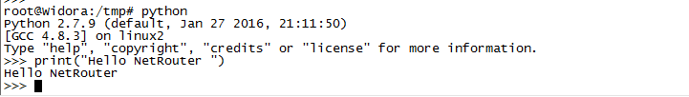
输入Use exit() or Ctrl-D (i.e. EOF) to exit 退出python环境

环境正常。接下来进行python学习。请滴卡上车~~

